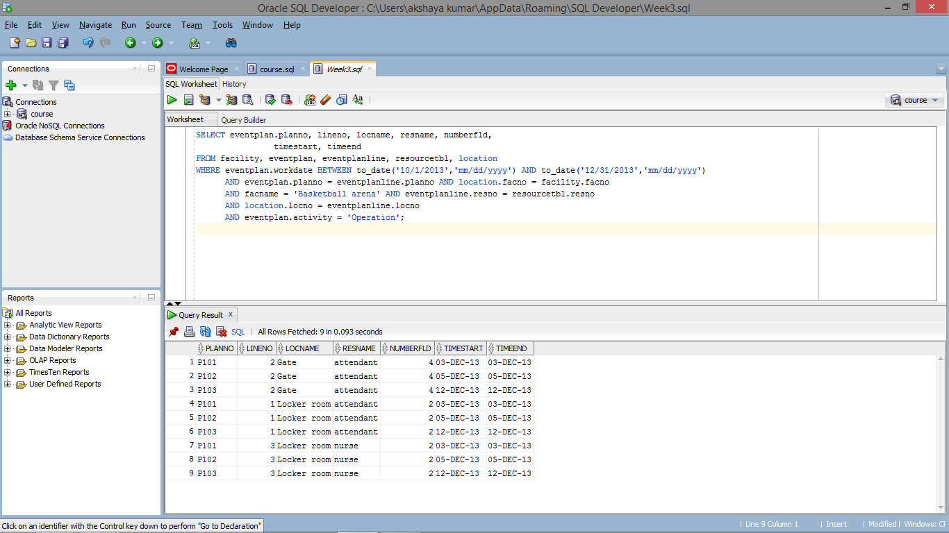

SELECT eventplan.planno, lineno, locname, resname, numberfld,

timestart, timeend

FROM facility, eventplan, eventplanline, resourcetbl, location

WHERE eventplan.workdate BETWEEN to_date('10/1/2013','mm/dd/yyyy') AND to_date('12/31/2013','mm/dd/yyyy')

AND eventplan.planno = eventplanline.planno AND location.facno = facility.facno

AND facname = 'Basketball arena' AND eventplanline.resno = resourcetbl.resno

AND location.locno = eventplanline.locno

AND eventplan.activity = 'Operation';